**TEACHER DESKTOP SCHEDULER (TDS)**

User Guide

This document will familiarize the following users with the TDS Suite online application:

* Teachers
* Learning Coaches
* Administrators

**Getting Started!**

**Teachers**

Once you’ve launched the application, you’ll notice that the default view for the TDS scheduler is the *Daily View*. We’ll look at the icons in a moment. But first lets look at the heart of the TDS, the Scheduler.

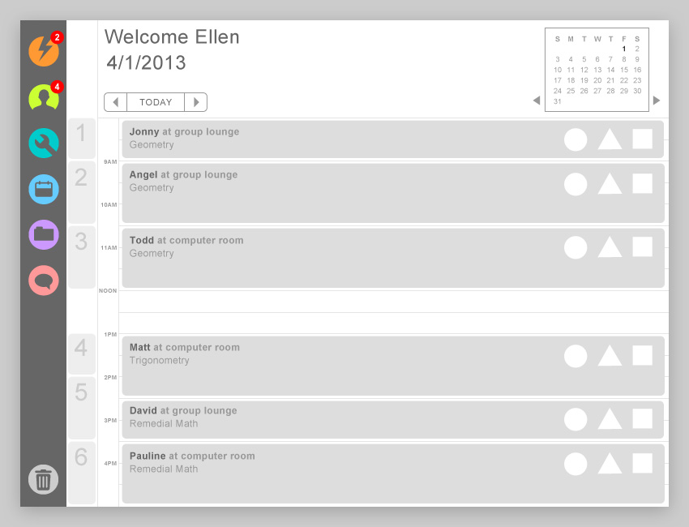

***Daily View***

In the Daily View the scheduler displays the periods/classes for that day. The only event or task that will be displayed in the Daily View is a task or event that *will require your presence and personal involvement*. Teacher specific events include\*1:

* Teacher lead
* Tutoring
* Interventions

A *Tutoring* event is a one-on-one event with a student, not directly related to an Intervention. An *Intervention* event is a tutoring session that is directly related to a specific student intervention.

As you move your cursor over your daily schedule, each individual period or class will be highlighted as you roll over.

The Daily view is designed to remind you, at a quick glance, of the events or task that will require your personal attention and time for any given period or class.

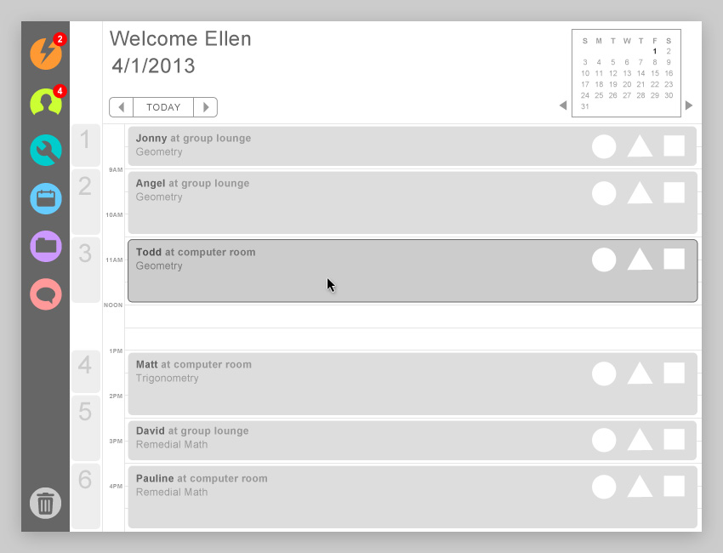

*Viewing Different Days*

To view your daily schedule for different days, you can click on the arrow buttons to the right and left of today’s date to view your daily schedule for the next five days or previous five days.

**NOTE:**  *Once you begin viewing your daily schedule for any other day than the current date, the Today button towards the bottom of the scheduler will become active. Click on the Today button to return to Today’s schedule*.

Clicking on the Calendar button at the top right of the scheduler will launch a smaller Calendar. You can use this calendar jump to any day in any week, in any specific month to view daily and class assignments for both you and your students.

Clicking on a period or class when it is highlighted will change the schedulers view to the *Class View*.

***Class View***

The Class View snapshot of who’s doing what, with whom, and where. The Class View is designed to very quickly allow you to see what each student’s assignment is for that period.

All of your students can be found in one of the following groupings \*2:

* Foundational
* Conceptual
* Collaborative
* Personal
* Wet lab
* Teacher Led

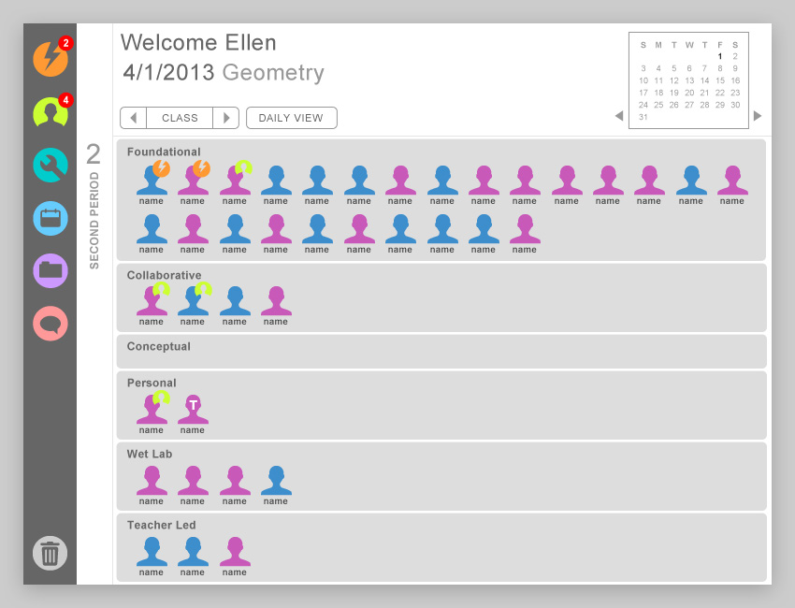

*Student Details*

An important part of the Class view is being able to see exactly what a student’s assignment is during that period. By clicking on any student Photo Icon, a *Student Details Panel* will slide out from the right side of the Scheduler that displays any specifics or details regarding the assigned lesson or the student.

\*\*Student photos vs. Student icons.

If you would like to see the actual that the student is assigned, clicking on the Lesson title in the Student Detail Panel will launch the eSchoolware lesson in a viewing window.

You can close the viewing window by clicking anywhere outside of the viewer and can close the detail panel by clicking on the ‘X’ Button at the top right.

At times you may notices smaller icons attached to student photos. These icons allow you to quickly identify students who:

* Are currently assigned Intervention specific material
* Are currently assigned material specified by a Personal Learning Plan (PLP)
* Have been assigned to tutor another student

Finally, at times you may see a Teacher or Aide icon in your Class View that will remind you that another non-student individual will be present in your class.

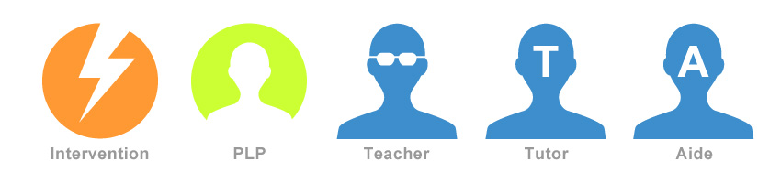

**NOTE:** *We’ve already discussed how you can view the actual lesson that a student is assigned. This holds true of a student with a Intervention icon affixed to his photo. Clicking on the lesson in his Student Detail panel will display that Intervention learning object (lesson).*

*However, when clicking on a student that has a PLP icon affixed to his photo, not only will the Student Details panel display the lesson that student is currently assigned, but will also provide you with a link to that student’s PLP. Clicking on that link will launch that student’s PLP should you wish to review it.*

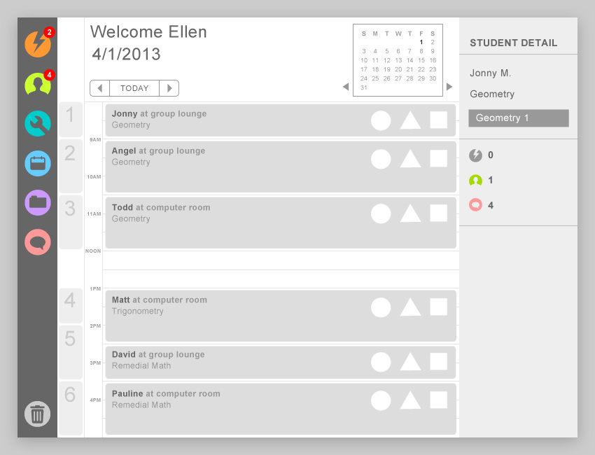

*Adjusting Student Assignments*

Note that you can drag any student photo from one grouping to another. This allows you to make adjustments to any student assignment ‘on-the-fly’.

Perhaps you’ve scheduled a tutor to meet with a student and in reviewing the daily assignments of class, you remember that another student is struggling with the mastering the same skill. Even though that student may currently be assigned to work on foundational material in eSchoolware, you can drag that student’s icon to the Personal grouping to add him to the current Tutoring session that is scheduled.

<< PROVIDE ADDITIONAL CASE FOR MOVING STUDENT>>

We’ll learn more about powerful tools in TDS that allow you to customize and adjust a student’s assignments in one of the following sections.

*Viewing Different Days*

By default, the Scheduler will display the current date’s Daily view and corresponding Class views. If you would like to review or edit a future schedule, you can click on the right arrow button next to the current date. Likewise, if you wish to review any of the previous five day’s schedules, you can click on the left arrow.

Macintosh HD:Users:kokupark:Desktop:Silo 6:1. wireframes:_Manual:manual.TDS.button.today.jpg

If you do click on either arrow, the Today button will become active. Click on it to return to today’s daily schedule.

Note, though that using the arrow buttons will only allow you to see on the previous five day’s schedule, or the schedule for the next five days.

If you would like to review or edit a schedule that is more than five days away, or perhaps weeks or months, use the Calendar on the top right corner of the TDS.

You should be aware that if you’ve drilled down to the Class view, clicking on the right arrow will bring you to your next *Class view*, not your next Daily view. You’ll notice that the Today button has automatically changed to Class. Clicking on Class will bring you back to the original Class View you were viewing.

***Icon Bar***

To the left of the Scheduler, you’ll find six icons. These icons are:

* Intervention
* Personal Learning Plan
* Custom Learning Object
* Student List
* Resources
* Messaging

Lets examine each icon to find out its purpose and how it relates to the Scheduler.

*Macintosh HD:Users:kokupark:Desktop:Silo 6:1. wireframes:_Manual:manual.TDS.icon.intervention.jpg* *Intervention Icon*

When a new Intervention is triggered, a red circle with a corresponding number of new Interventions, is displayed atop the Intervention Icon. Once you click on the Intervention icon the new Intervention number will disappear and a drop down menu will slide out.

On the slide out menu, you will see a list students who have been assigned an intervention. Newest students are always listed first, followed by students who have not yet cleared their intervention.

You can click on the names in the drop slide out menu at any time to launch the Intervention interface, which we’ll discuss in a moment. However, TDS is designed to automatically assign the student a Learning Object covering the same skill that the student failed to master in his lesson.

TDS will provide a three question mini-assessment after the student completes the auto-assigned learning object. Should the student pass the Intervention mini-assessment, the student will be allowed to continue on to the next lesson and his name will no longer appear in the Intervention slide out menu.

If a student does not pass the intervention mini-assessment, TDS will continue to assign a new learning object related to the lesson until the student passes the mini-assessment associated with an intervention assigned lesson, or there are no more lessons to be auto-assigned.

Macintosh HD:Users:kokupark:Desktop:Silo 6:1. wireframes:_Manual:manual.TDS.icon.exclamation.jpg If you see the Red Exclamation icon next to a name in the Intervention slide out menu, this is an indication that there are no more learning objects that TDS can auto-assigned. You will need to take one or both of the following actions:

1. Assign a tutor to the student
2. Create a Custom Intervention Learning Object for the student

You can do either of the above by clicking on the student’s name on the Intervention slide out menu. Clicking on a student’s name in on the Intervention slide out menu will launch the *Intervention Interface scree*n. We’ll discuss exactly how the above actions are accomplished when we review the Intervention Interface Screen in detail.

Macintosh HD:Users:kokupark:Desktop:Silo 6:1. wireframes:_Manual:manual.TDS.icon.PLP.jpg *Personal Learning Plan Icon*

Very similar to the Intervention Icon, the Personal Learning Plan (PLP) icon and slide out menu, will display students who have recently had an adjustment made in their PLP that requires the student take a specific course of action or be assigned a specific learning object.

Once again, a red circle with the number of new PLP alerts will display on the PLP icon on the menu bar. Once you click the icon, the red circle and number will no longer be shown.

The list of Students displayed in the PLP slide out menu will be sorted by the students with the most recent PLP alert, followed by students who have not yet complete a task tied to, or prescribe by the student’s PLP.

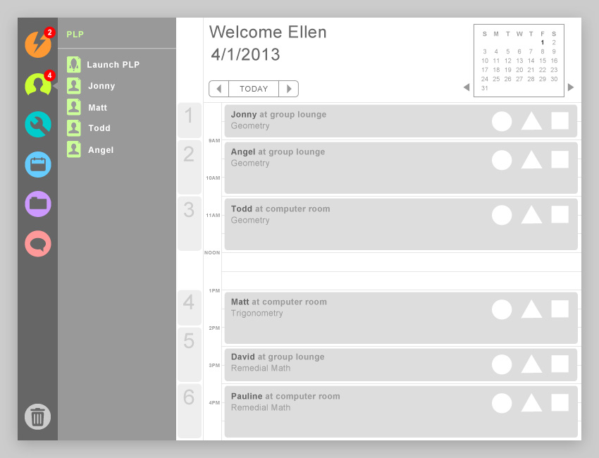

Clicking on a student’s name in the PLP slide out menu will launch the *PLP Screen*.

Because the Learning Coach is responsible for reviewing and editing the PLP and setting appropriate goals, you will only be able to review the Personal Learning Plan, but not edit the PLP \*3

In addition, TDS will use the goals that the Learning Coach has set in the PLP to *automatically assign appropriate learning objects for the student*. If there is action required on your part in relation to a PLP goal set by the Learning Coach, the red exclamation alert icon will appear next to a student’s name.

If you click on a student name with the read exclamation mark alert, the PLP Interface screen will launch and open to the specific screen that displays the reason for the alert and any actions that you will need to take. Any notes provided by the Learning Coach will also be available to you on that screen. You can add your comments and or respond to the Learning Coach or student from that same screen.

Once the goal for that student has been met, that student’s name will no longer appear in the PLP slide out menu.

If you would like to view the PLP of a student that is not in your PLP slide out menu, click on the Launch PLP icon to pull up the PLP Interface screen.

We’ll learn more about the Personal Learning Plan Interface screen (or Wizard) later in this User Guide.

*Macintosh HD:Users:kokupark:Desktop:Silo 6:1. wireframes:_Manual:manual.TDS.icon.CLO.jpg* *Custom Learning Objects*

Each eSchoolware Lessons are composed of a number of related Learning object. At times you may wish to create a custom learning object. In and intervention, when there are no more learning objects for TDS to auto-assign to the student, you may wish to create a custom learning object before assigning a tutor. Or you may find that you would like to create supplemental learning objects for a student, a class or a specific course.

Clicking on the Custom Learning Object (CLO) icon will display a slide out menu. To create a new Custom Learning Object, click on the CREATE NEW icon at the top of the slide out menu. Doing so will launch the Custom Learning Object interface screen.

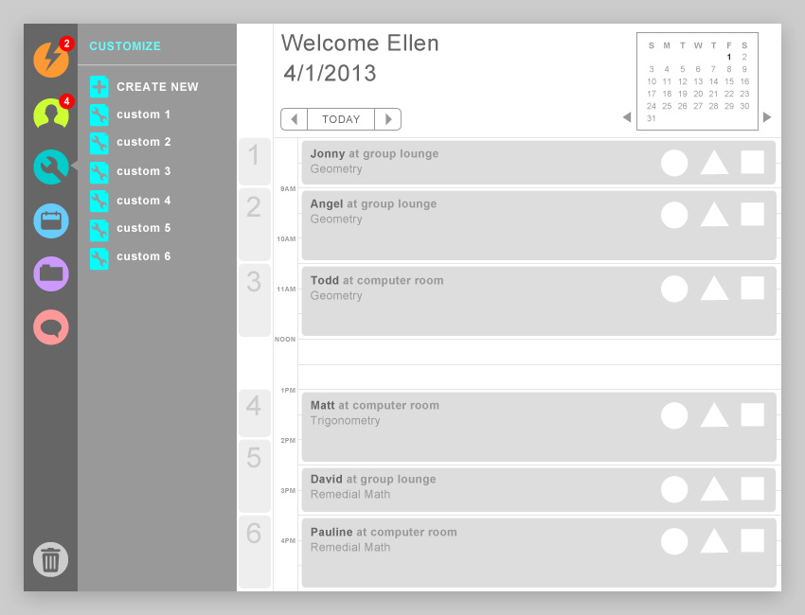

Any custom learning object that you create will be listed in the slide out menu for the CLO icon. If you click on any existing CLO in the menu, the CLO Interface screen will be launched with the content of that specific CLO so you can start editing that CLO right away.

You will also be able to access your CLO library from the CLO Interface screen. At this point, your CLO Library will only be able to see, review, edit and assign CLOs that you have created \*4

NOTE: The CLOs displayed in your CLO slide out menu are populated by the class period you currently have selected in your TDS scheduler. If upon launching TDS you click on second period, the CLOs listed will be learning objects you have created for that class/course.

If you would like to review, edit or assign a custom CLO for another class, simply click on the class or period in your Scheduler.

The slide out menu for CLOs is designed this way so that you can easily drag and drop a CLO onto a student icon in Class View to assign a CLO. This is quick and powerful. But keep in mind there are other ways to assign a CLO, which will be discussed when we explore the CLO Interface screen.

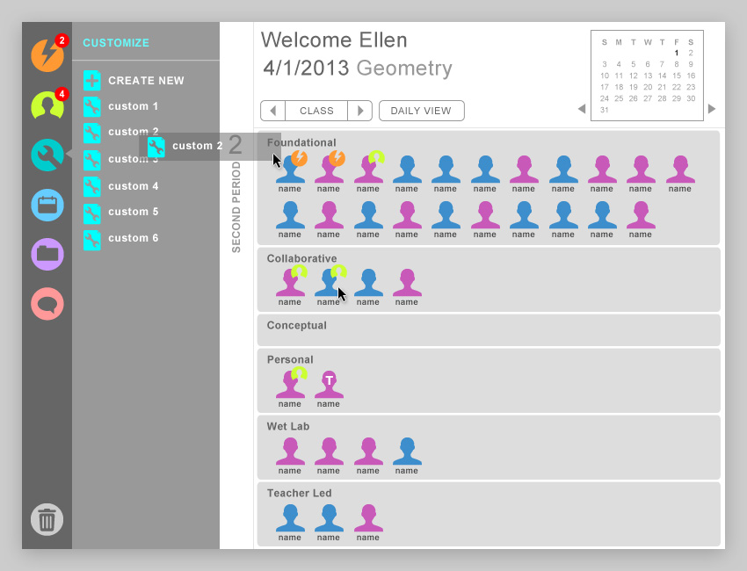

*Drag a Custom learning object to a student to change the student’s assignment.*

Macintosh HD:Users:kokupark:Desktop:Silo 6:1. wireframes:_Manual:manual.TDS.icon.student.jpg *Student List*

Similar to the CLO slide out menu, the Student List slide out menu is populated based on the class or period that is selected in the Scheduler. If no period is currently selected , TDS will use the time of day to decide what students are displayed in the Student List menu.

One of the important functions available when clicking on the Student list is the Roll Call interface.

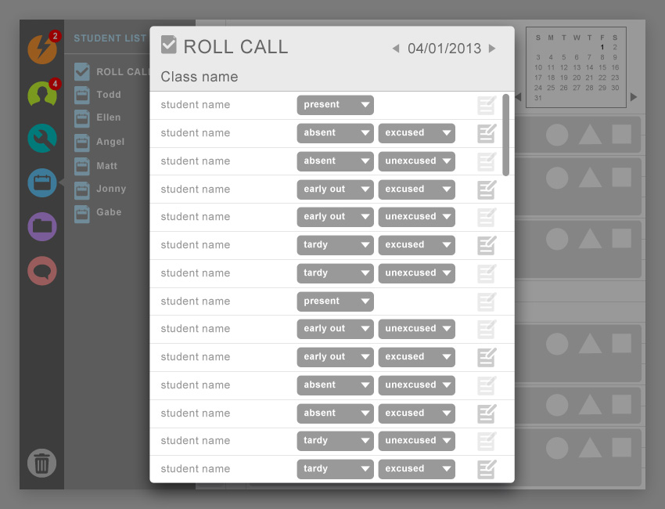

The Roll Call interface allows the teacher to take class attendance in the TDS. This information, absences, tardies, etc. will be used to help define and track Personal Learning Plan goals.

The Roll Call interfaces is relatively straight forward. You can set the state of the student. If the state you choose is ‘excused’ either for an absence or tardy, the *note icon* to the far right of the student name will highlight. This will prompt you enter the excuse.

Since this is or Class attendance only, there most likely will be very little changes to the state of the Roll call interface for any class. However, if any changes are made to the eSchoolware system by any other means, this information will automatically update the TDS Roll Call interface.

Returning back to the Student List slide out menu, clicking on any student name in the menu, will open up the Student’s *Class Assignment view*. The Class Assignment view displays that student’s assignment for the period.

Clicking on the Student’s Class Assignment view, will open a slide out detail panel on the right side of TDS that also allows you to review a number of details related to the Student including viewing his PLP or sending a message to the student.

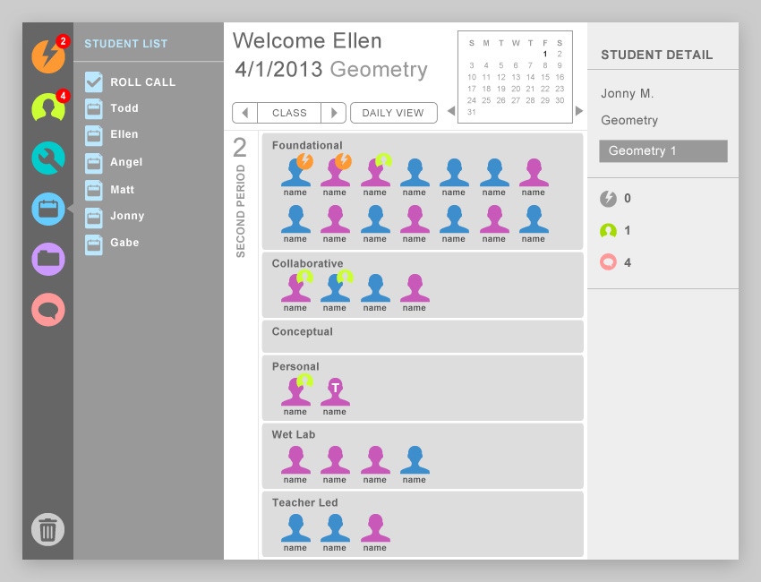

Returning to the Class Assignment view we can discuss one of the view’s advantages. In the Class view, you could open the CLO slide out menu and drag a CLO onto the Student’s Photo or icon to assign a CLO. When we review the Resource Menu in just a moment, you’ll see that this drag and drop method is a quick and easy way to assign curriculum to a Student.

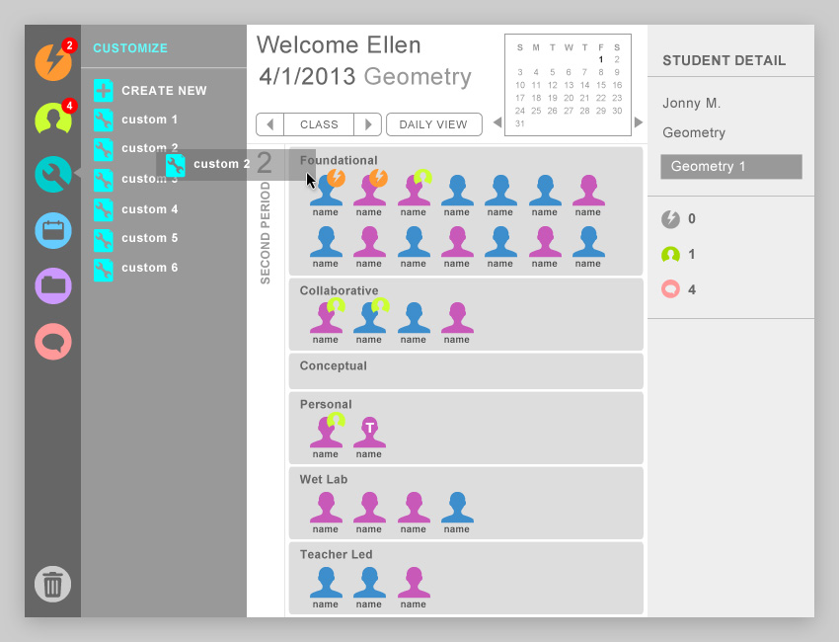

All the features and tasks available in TDS are tightly integrated and allow you, the teacher, multiple paths to access information or accomplish a given task.

Macintosh HD:Users:kokupark:Desktop:Silo 6:1. wireframes:_Manual:manual.TDS.icon.resources.jpg *Resources Icon*

When you click on the Resources icon, you’ll notice the slide out menu is divided into three sections:

* People
* Curriculum
* Physical

These are resources that you can ‘drag’ and assign to any student when you are in the Daily View, Class View or Student Assignment view.

The resources found in the *People* category are currently:

* Teachers
* Aides, Administrators
* Learning Coach
* Online tutors or students \*5

Clicking the Add Resource button on the menu allows you to add resources to any respective category.

Note: Adding a new resource to the People category will launch the Tutor Manager Interface. There will be more information on the Tutor Manager Interface later.

Items found in the Curriculum category represent curriculum resources available for you to assign to a student. These sources include:

* eCourses (could be Course Player, MyDay, or Traditional View course)
  + Foundational Content (lessons and assessments)
  + Collaborative (lesson page)
  + Conceptual (lesson page)
  + Personal (lesson page?)
* eValuate assessments
* Interventions (learning objects and mini-assessments)
* Diagnostics
* Teacher-created content items (CLO)

The last category is Physical Resources. Physical resources can include:

* Room (may contain other physical resources)
* Meeting area (may contain other physical resources)
* Wet Lab (may contain other physical resources)
* Desk (no computer)
* Workstation computer
* Laptop computer
* Tablet

Clicking the Add Resource button for any of the categories will launch an interface that will allow you to enter information about the resource you are adding.

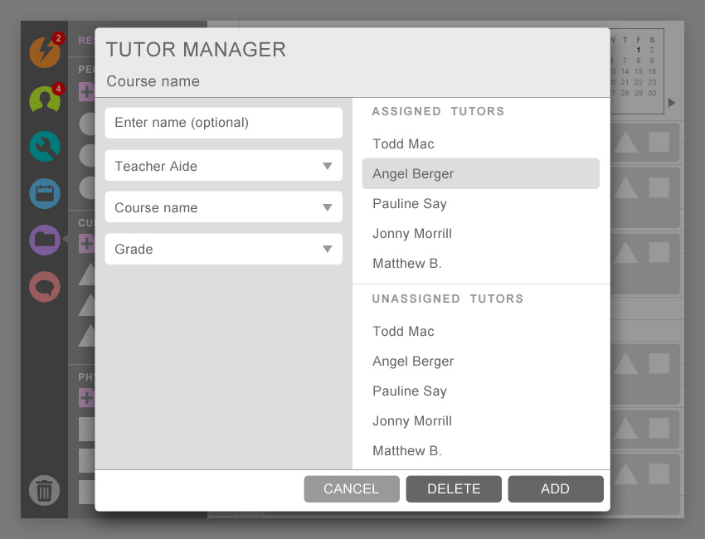

**[IMAGE: Add resource interface]**

**[IMAGE: Add Physical resource interface]**

*Assigning Resources*

We’ve already introduced the drag and drop method of assigning content to a students with Custom Learning Objects. Assigning resources is very similar when using the Recourses Slide out menu when you are in the Student Assignment view.

To assign a teacher, aide or other tutor to a student, drag that person’s Photo icon on to the Scheduler next to the Student photo icon. Remembering that much of what is populated in the Menu is tied to the Class and student selected in the Scheduler, any human resources that are available in the Resource menu when in the Class Assignment view, should already be individuals who are familiar with that course or subject. Very likely, TDS has also included them because they are available for that time period as well.

However, since the population of the Human resources category is based on the Teacher or Aide’s course familiarity as its primary filter, it is possible that when dragging a tutor or aide to the Students Assignment screen an ‘Unavailable’ alert may be displayed.

In that case you will simply need to assign another individual.

To assign specific content, drag the appropriate Curriculum Icon (evaluate, eCourse etc.) from the Curriculum Resource area to the Student’s photo icon. When you do this a Content Selection Dialog will pop up that will allow you to find and assign the appropriate eCourse lesson, eValuate assessment or diagnostic etc.

**[IMAGE: Content Selection Dialog box- very similar to the dialog box to find a file on your computer]**

Assigning a physical resource to a student or a student to a resource, is as simple as dragging the Physical resource Icon over to the Student’s photo icon. Again, only available physical resource will be displayed in the Physical Resources area of the slide out menu based on the class currently highlighted in the Class view.

Macintosh HD:Users:kokupark:Desktop:Silo 6:1. wireframes:_Manual:manual.TDS.icon.messaging.jpg Messaging Icon

When you click on the Messaging Icon you’ll notice that the side out menu provides you with the interface to effectively communicate with anyone at your institution. However you will have to Add the specific individuals you will wish to communicate with be they tutors, other teachers, the administrator or students.

Once you’ve added an individual to your list, all you need to do is click on that person’s name and beginning typing your message in the Type/chat area. The Messaging feature will store the conversation for a default period of one month.

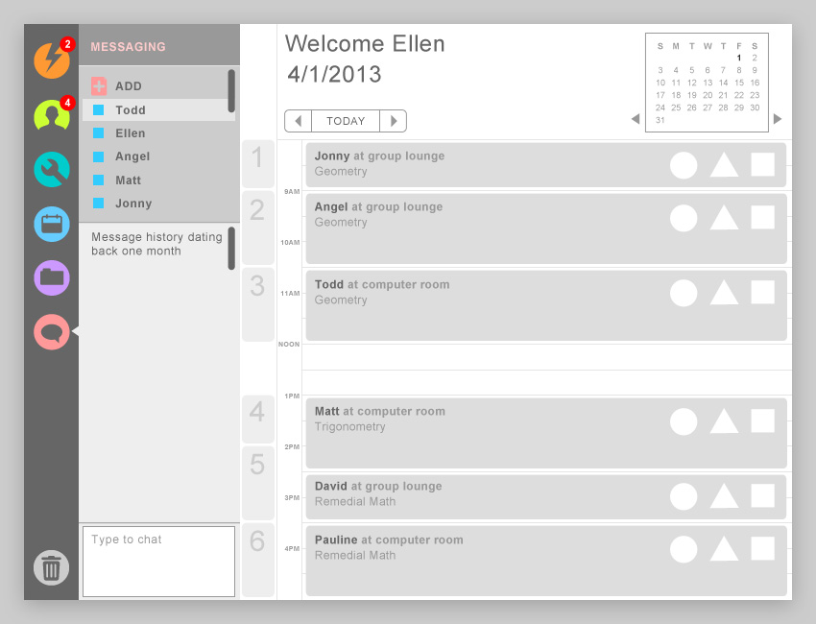

Note: Some other Interfaces like the PLP require a user to enter a message. While the message is entered in the PLP interface in that instance, it will be routed to your Messaging tool.

Currently the Messaging feature does not support group messaging.

Macintosh HD:Users:kokupark:Desktop:Silo 6:1. wireframes:_Manual:manual.TDS.icon.trash.jpg Trash Icon

If you are using a feature (PLP Wizard, Scheduler, Intervention Interface) that allows you to delete a specific object in that feature, the Trash Can icon will become active. When the Trash can icon is active, you can simply drag the object you wish to delete to the Trash can icon.

Macintosh HD:Users:kokupark:Desktop:Silo 6:1. wireframes:_Manual:manual.TDS.icon.trash.grayed.jpg Macintosh HD:Users:kokupark:Desktop:Silo 6:1. wireframes:_Manual:manual.TDS.icon.trash.jpg

Items that can be deleted include:

* Custom Learning Objects
* Intervention Notifications
* Human Resources
* Curriculum Resources
* Physical Resources

Currently only the Administrator can delete Teachers or Students.